Research

How to make a website attractive to teenagers:

*“The younger audience is much more tech savvy than previous generations, and their values and styles of shopping and using the internet have changed. In summary, millennials are after a few things: fast and convenient information, content that’s funny and personal, and products and services that focus on their long term goals rather than instant gratification”* (Source 1).

* Mobile access has to be a must. I have to be able to make a website that resizes depending on the size of the screen that the person is using.
* *“Millennials and Generation Z youth want to see that you stand for a cause and want to help the world at large to some extent.”* (Source 1). This will belong on my ethics section in the about me’ page.
* Different stereotypes: *“they just want to be entertained online with graphics and multimedia, are supremely tech savvy, use smartphones for everything, and want everything to be social.”*(Source 2). This means that in order to engage my target audience I’m going to have to create a website that contains many multimedia content that looks friendly and engaging.
* Students from the research done by Source 2 indicate that the Generation Z uses websites mainly for this reasons: *“School assignments, Hobbies or other special interests (including learning new skills or finding fun activities), Entertainment (including music and games), News (including sports, current events, and entertainment), Learning about new topics, Talking to friends, and Shopping.”(Source 3)*
* But Teens (my target audience) also have attributes that are going to affect my approach on the design of the website such as: some teenagers have *“Insufficient reading skills” and also have “Dramatically lower levels of patience”* (Source 2), which means that the website must look and perform efficiently because any errors might scare the users away.
* *“A typical high school aged information seeker (14-18 years old) has a short attention span, is easily bored, and prefers scanning material quickly instead of reading.”* (Source 3)
* *“Youth information seekers will tend to gravitate to sites that are easy-to-use, have clean designs with “cool” graphics, and contain interactive features such as online quizzes, voting, and games.”* (Source 3). I was already planning to do trivia and quizzes in order to help students revise for the exams. This would help my website be more engaging to the users and will therefore be more useful for them.
* *“Youth tend to be repelled by sites with visual designs perceived as “kid” focused including childish content, images, or colour schemes”* (Source 3). Based on this piece of research, I will try to design my website in a way that teens don’t feel they are being treated like children, but like young adults instead.
* 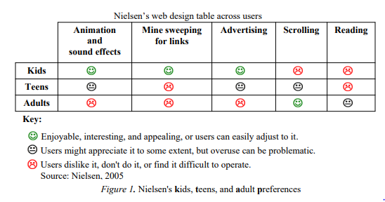Based on this graph from *Source 3*, is fair to assume that teens are one of the most demanding age groups as their requirements from a website are quite high and meticulous.
* Do: animation effects eg. Info carousel.

Do: add some scrolling to the page.

Don’t: add advertising.

Don’t: create long texts.

Research the national curriculum:

Programming, website design…: